General welfare requirement: Safeguarding and Promoting Children’s Welfare
The provider must promote the good health of the children, take necessary steps to prevent the spread of infection, and take appropriate action when they are ill.

Promoting health and hygiene
1.20 First aid
Policy statement
At Gorran Pre-School Hoglets staff are able to take action to apply first aid treatment in the event of an accident involving a child or adult. All member’s of staff hold a paediatric first aid training is on the premises or on an outing at any one time. The first aid qualification includes first aid training for infants and young children.
EYFS key themes and commitments
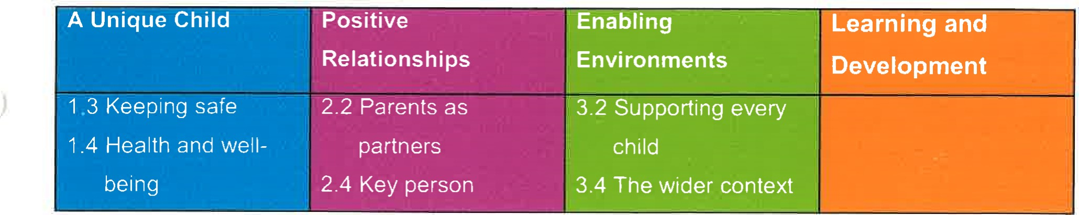

Procedures
Our staff member Michelle Beard is responsible for regularly checking the first aid kit and ensuring all items are well stocked and in date.
The First Aid Kit
Our first aid kit complies with the Health and Safety (First Aid) Regulations 1981 and contains the following items only:
- Triangular bandages (ideally at least one should be sterile) - x 4.
Sterile dressings:
  - Small (formerly Medium No 8) - x 3.
  - Medium (formerly Large No 9) — HSE 1 - x 3.
  - Large (formerly Extra Large No 3) — HSE 2 - x 3.
- Composite pack containing 20 assorted (individually-wrapped) plasters 1.
- Sterile eye pads (with bandage or attachment) eg No 16 dressing 2.
Container or 6 safety pins 1.
Guidance card as recommended by HSE 1.
In addition to the first aid equipment, each box should be supplied with:
- 2 pairs of disposable plastic (PVC or vinyl) gloves.
1 plastic disposable apron.
- a children's forehead 'strip' thermometer.
- The first aid box is easily accessible to adults and is kept out of the reach of children.
No un-prescribed medication is given to children, parents or staff.
At the time of admission to the setting, parents' written permission for emergency medical advice or treatment is sought. Parents sign and date their written approval.
- Parents sign a consent form at registration allowing staff to take their child to the nearest Accident and Emergency unit to be examined, treated or admitted as necessary on the understanding that parents have been informed and are on their way to the hospital.
Legal framework
- Health and Safety (First Aid ) Regulations (1981)
.1
Further guidance
- First Aid at Work: Your questions answered (HSE Revised 2009)
- Basic Advice on First Aid at Work (HSE Revised 2008)
Guidance on First Aid for Schools (DfEE)

This policy was adopted at a meeting of
Held on

Gorran Pre-School Hoglets name of setting October 2019 (date)

Date to be reviewed October 2020 (date)

Signed on behalf of the management Michelle Beard committee

Name of signatory Michelle Beard

Role of signatory (Manager) Pre-School Leader/Nominated Person

